**Activity 6**

**Learning Outcome :** Able to install and configure the different types of network device in a network

**Aim :** Install and Configure VPN

**Requirement :** Cisco Packet Tracer

**Procedure :**

**1. Create two LAN network using Router , Switch and PC’s.**

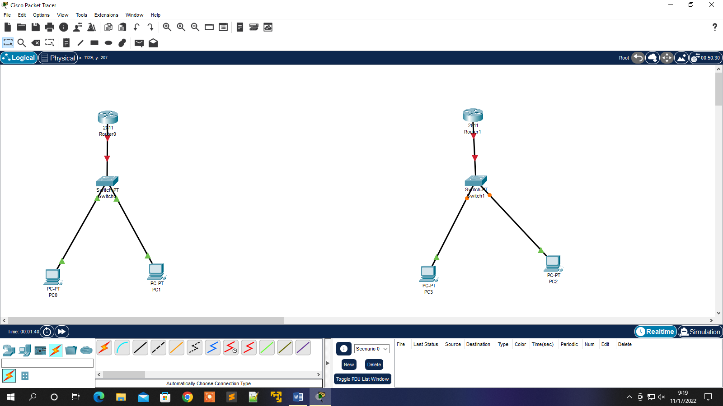

**2.Assign IP Address to Both network and also to PC’s**

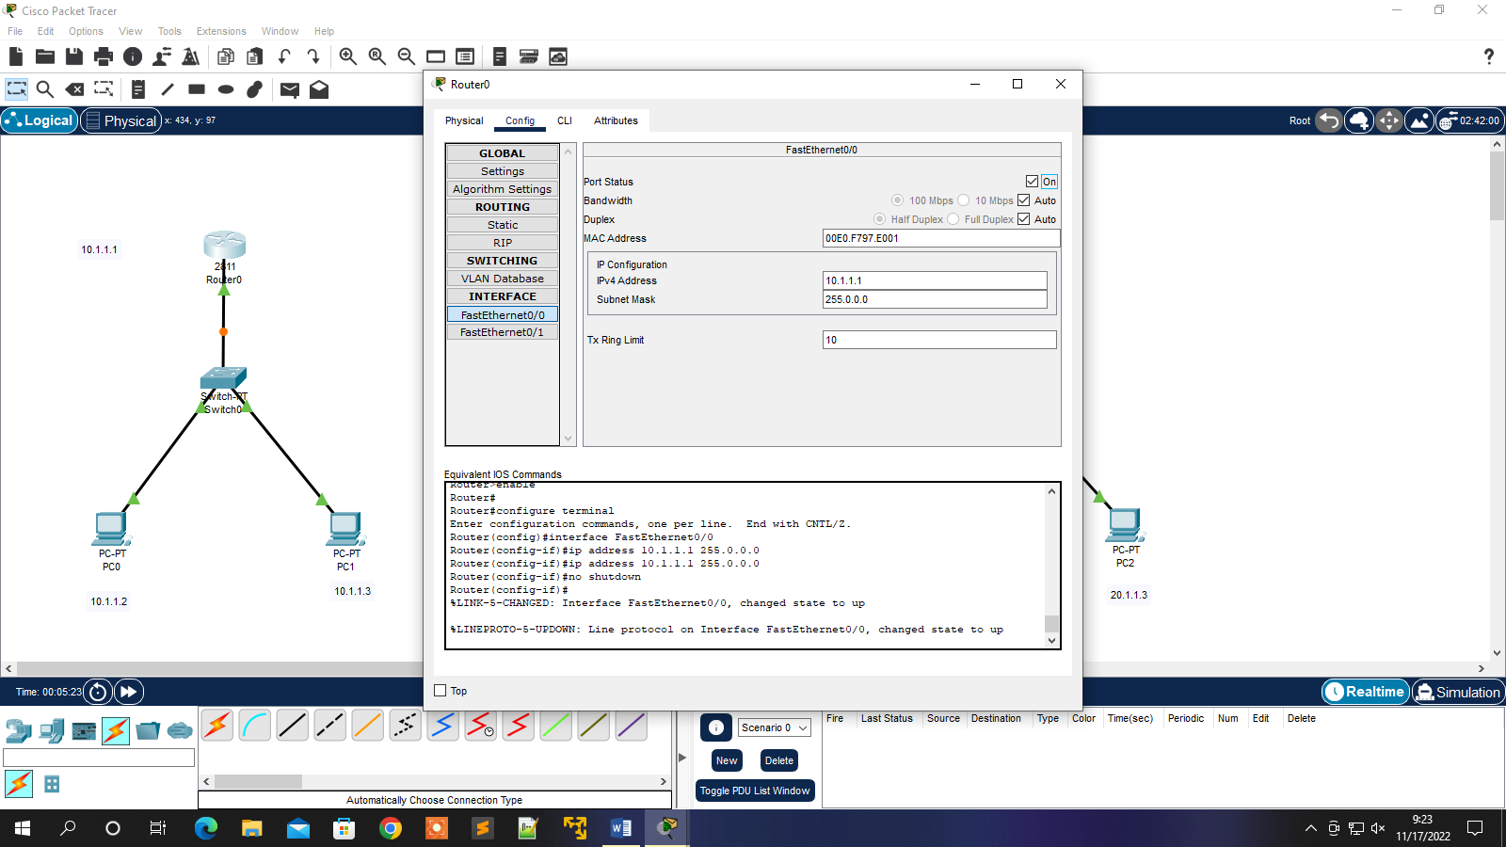

**3. Install two more router between the preinstalled router to connect both network. Connect all the router through Ethernet cable**

**4. Assign IP Address to all the routers**

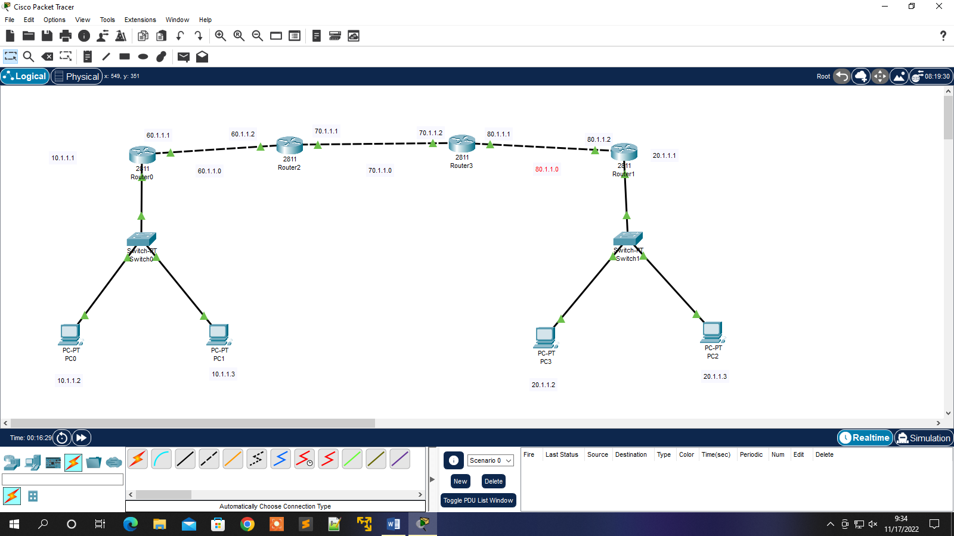

**5. Configure RIP protocol**

* **Click on each router ,select RIP**
* **Enter IP address of fa0/0 and fa0/1**
* **Click on “Add”**

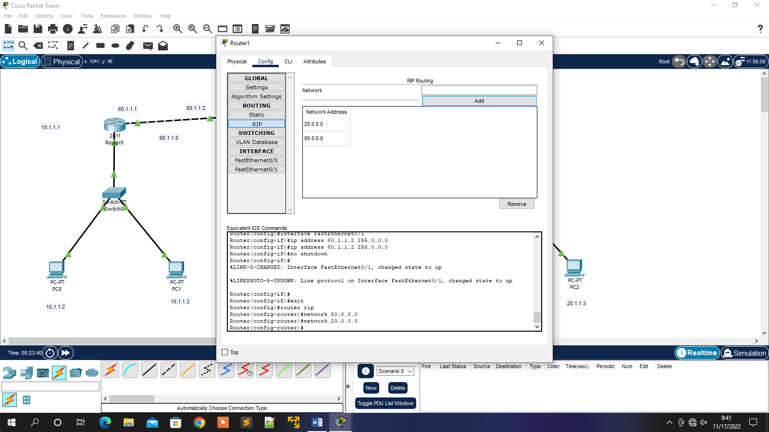

**6. Create VPN Tunnel and give IP address to both ends of tunnel.**

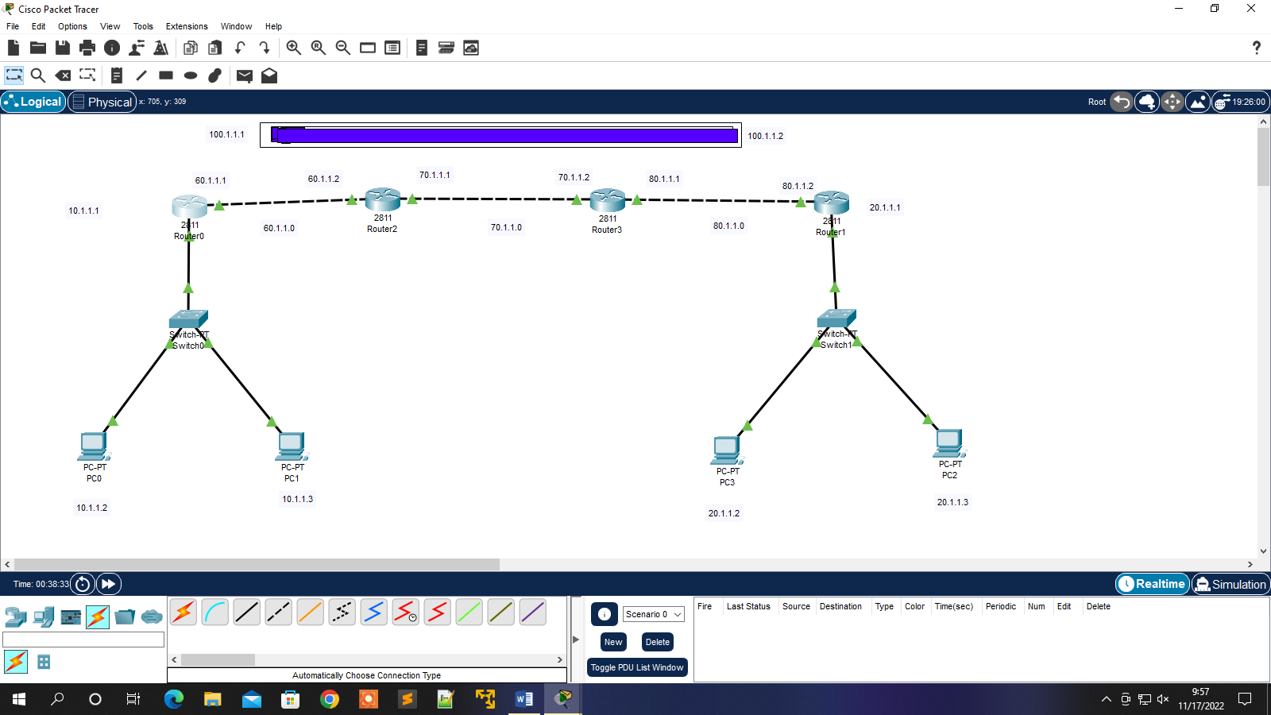

**7. click router0 ,go to CLI and run the commands given below**

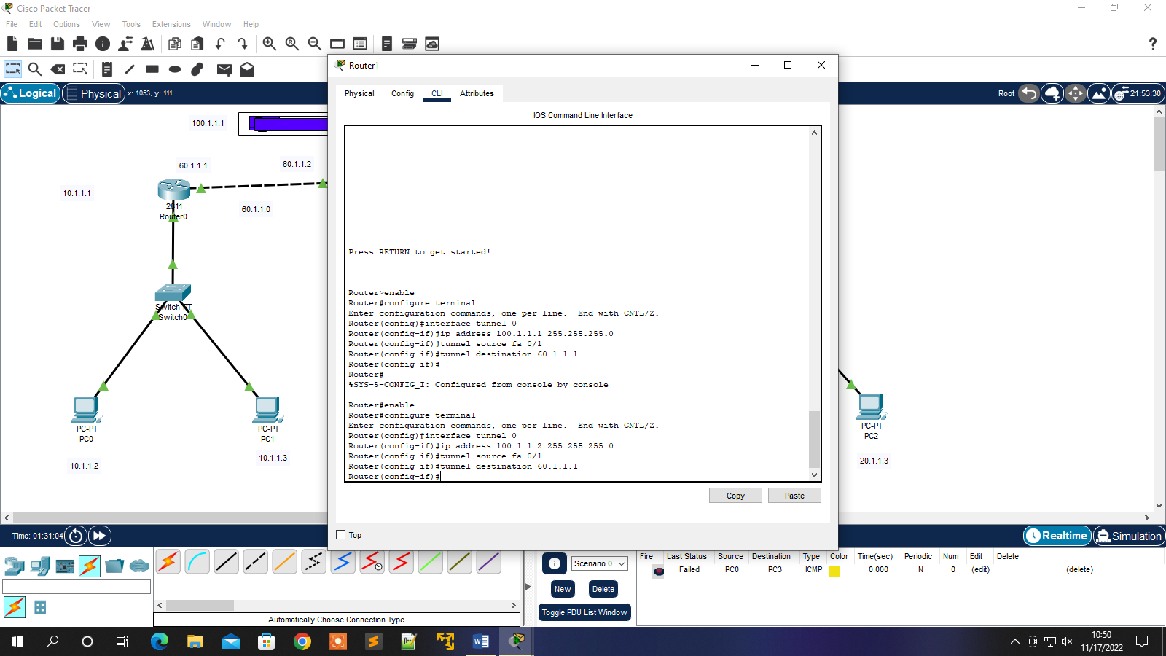

**8. Do same in Router 1**

**9. Open the command prompt of PC and run tracert command to trace the route of the packet.**

